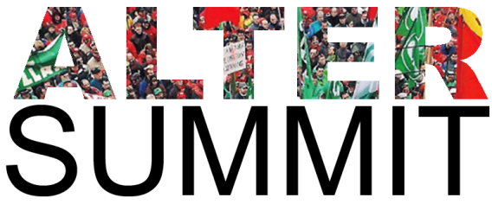

Dear candidate,

In the name of the Alter Summit[1], a Europe-wide coalition of trade unions and organisations working on ecological, social and economic rights, we find it of the utmost importance to inform the voters about candidates’ opinions and commitments on key matters. We therefore invite you to answer to following questions. These questions are derived from the Manifesto of Athens which describes the Europe we want, on one side, and our will to enhance democracy in Europe, on the other hand. As far as possible, we invite you to clearly answer by Yes or No and, when you deem it appropriate, to add an explanatory comment to your Yes or No answer. Your answers or reaction – whatever they are – will be published.

**Part 1: Our Manifesto for another Europe**

**I) Budgetary policies**

Do you agree that:

1. Austerity and deregulation policies and programmes which are driving Europe deeper into recession, must be stopped (i.e. REFIT programme),
2. Fiscal Pact, Six-Pack and Two-Pack must be cancelled,
3. An important share of public debt must be cancelled without harming small bondholders, savers and pensioners,
4. European Central Bank and other public banking institutions must be mandated to directly lend to States at low interest rates and under democratic control without such lending being linked to privatisation or deregulation?

**II) Fiscal policies**

Do you agree that:

1. Revenues, wealth and profits must be submitted to a just, progressive and permanent taxation system, with an effective minimum rate applied in all Member States of the EU,
2. Financial transactions must be taxed,
3. Tax havens and off balance sheet activities must be forbidden and bank secrecy rules must be abolished?

**Part 2: Regulation of the financial sector**

Do you agree that:

1. Extensive guarantees granted to banks must be reviewed and shareholders of banks must take their share of the losses,
2. Commercial and investment banks must be completely separated,
3. Banks that are “too big to fail” must be broken up,
4. Banks and financial institutions must be submitted to democratic control,
5. Priority must be given to public and cooperative public credit systems?

**Part 3: Transatlantic trade and investment pact**

Will you reject the transatlantic trade and investment pact – or of any other agreement - if it contains one of following dispositions:

* Dispute settlement mechanism (private economic actors against States),
* Public services liberalisation (education, health systems, water distribution, transport, …)
* Regulatory convergence mechanism between US and EU with possible consequences on social rights and social protection, environmental protection, agriculture and food quality anf individual rights ?

**Part 4: Democracy in Europe**

I) Do you agree that any decision made - or agreement concluded - at EU level should respect following requirements at all stages of the decision-making process:

1. Clear explanation of the aim(s) of the decision and how this/these aim(s) relate(s) with human rights, social progress, quality of environment, social inclusion, poverty reduction, sustainable development (all aims included in the Treaty of the EU),
2. No participation to the decision making of any person, who has an economic interest in the decision to be made, is closely related to a person having such an interest and/or is under the influence or the power of such a person,
3. Full transparency on all stages and aspects of the decision-making process, including those contributed by or on behalf of lobby groups, advocacy groups, corporate interests, think tanks and others,
4. Social consultation whenever the proposed decision has or may have an impact of employment, labour law and/or social and economic rights ?

II) Do you commit to take initiatives aiming at ensuring effective implementation of the above mentioned requirements and principles you approve,

We thank you for your answers.

Kind regards.

Members of Altersummit network

1. To know more about the Alter Summit, please check : [www.altersummit.eu](http://www.altersummit.eu)