Letters

Time to end Israel's Gaza blockade
- The Guardian, Friday 27 December 2013 12.27 GMT
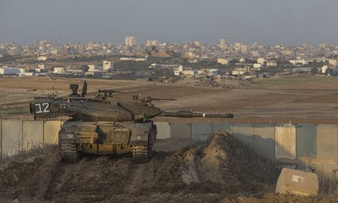
An Israeli tank patrols the Gaza border. British parliamentarians are calling for an end to the blockade that started five years ago. Photograph: Uriel Sinai/Getty Images
Today marks five years since the Israeli military launched missile and ground attacks on Gaza, which Israel named Operation Cast Lead. According to the UN, 1,383 Palestinians died as a result, including 333 children.
And what of the survivors? For the 1.7 million living in the tiny Gaza Strip, life has become increasingly desperate because of Israel's continuing blockade, backed by Egypt and with no effective challenge from governments around the world. The blockade has brought electricity cuts of 16 hours a day, which means the only street lights visible at night have been those from Israel's nearby towns. The electricity shortages have severely affected almost all essential services, including health, water, sanitation and schooling. With waste plants not operating, Palestinian children have been wading through freezing sewage to attend school. The terrible floods in Gaza brought the promise of increased electricity supplies for a few weeks, but the international community must demand that supply is constant and permanent.
This blockade has also resulted in unacceptable limits on personal freedom. Most Palestinians are prevented from travelling outside Gaza, an area of 139 sq miles: about the same size, but much more densely populated, as Newcastle. It is deplorable for us to allow this continuing collective punishment against Palestinians in Gaza. We urge the UK government to take immediate action to bring an end to the blockade on Gaza.
Baroness Blackstone, Peter Bottomley MP, Richard Burden MP,Martin Caton MP, Katy Clark MP, Michael Connarty MP, Jeremy Corbyn MP, Alex Cunningham MP, Lord Dubs, Mark Durkan MP,Lord Dykes, John Hemming MP, Julian Huppert MP, Lord Hylton,Hugh Lanning, Palestine Solidarity Campaign, Lord Judd, Caroline Lucas MP, Sir Gerald Kaufman MP, George Mudie MP, Grahame Morris MP, Sandra Osborne MP, Lord Phillips of Sudbury, Rt Hon Dame Joan Ruddock MP, Andy Slaughter MP, Baroness Tonge,Yasmin Qureshi MP, David Ward MP, Mike Weir MP

