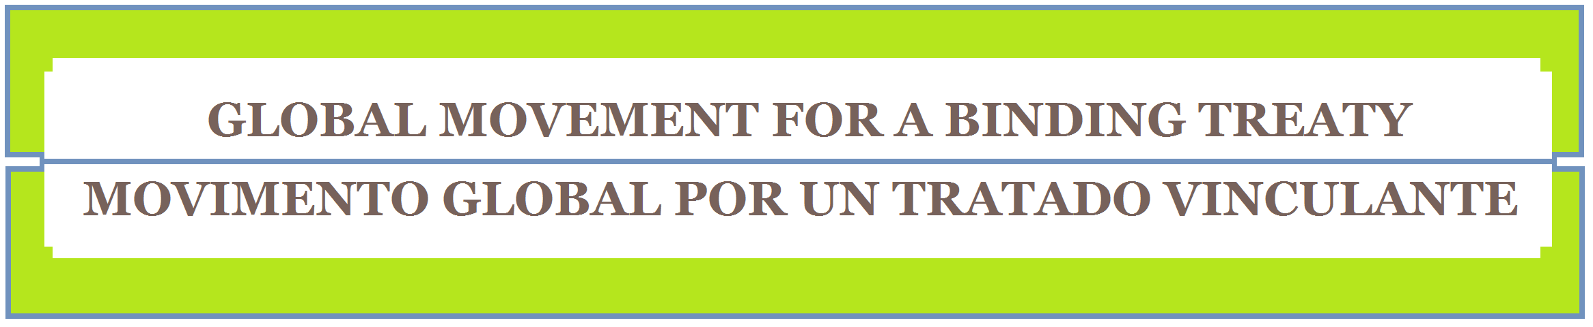

Social Movements, NGOs and Human Rights Groups
“Call on U.N. Human Rights Council to start developing a treaty to tackle corporate human rights violations”

PRESS RELEASE-May 7, 2014

Today a global alliance of civil society organizations (the Treaty Alliance), made up of a large group of civil society campaigns, networks, social movements and organizations from around the world, call on UN Human Rights Council members to support an initiative in June that would begin a process towards creating an international treaty to address corporate human rights violations.

The Treaty Alliance gathers global networks and alliances including Dismantle Corporate Power Campaign, ESCR-Net, FIAN, FIDH, Franciscans International, Friends of the Earth International, Transnational Institute and OMAL, among others, which collectively represent more than 500 groups world-wide who are determined to stop corporate human rights violations.

The Treaty Alliance is coordinating civil society actions in over 20 countries with the aim of ensuring that U.N. Human Rights Council (‘HRC’) member States support a HRC resolution at the 26th Session of the HRC in June. The aim of this UN initiative is to strengthen international law to ensure legal accountability for corporate human rights violations, as well as remedies and justice for affected people.

The Joint Statement of the Treaty Alliance, signed already by over 150 civil society organizations around the world, expresses their intention to mobilize collective support and advocacy for a treaty that would affirm the applicability of human rights obligations to the operations of corporations, have countries monitor and regulate corporations under their jurisdiction, provide for access to an effective remedy for the people affected by corporate human rights violations, as well as provide for an international monitoring and accountability mechanism.

Advocacy Actions
During May and June, advocacy and mobilization in national capitals will be taking place in Buenos Aires, Brasilia, Johannesburg, New York, Manila, Brussels, Oslo and elsewhere as well as in Geneva, in order to raise awareness of concerns about corporate human rights violations and the need for an international treaty. For information, ideas and support engaging in advocacy in your country contact treatymovement@gmail.com

As the 26th Session of the HRC gets underway in Geneva coordinated advocacy will take place both inside and outside of the UN buildings. In support of the on-going advocacy efforts inside the UN for binding instruments to stop corporate human rights violations, members of the Treaty Alliance will coordinate the Week of Mobilization, beginning June 23rd. Activities planned in this week include:

- [June 23] A Hearing of the Permanent Peoples’ Tribunal (PPT) on Global Corporate Crimes (Chevron, Shell, Glencore, and others);
- [June 24] Public Conference on TNC Violations, 8pm @ CETIM, Geneva
- [June 24-25] An International Conference on a Human Rights Compliant System for Food Production and Food TNCs
- [June 25] A march in front of the Palais des Nations and an ‘Impunity Tour’ in downtown Geneva.

For further information on the Week of Mobilisation contact treatymovement@gmail.com or Gonzalo Berrón: gonzalo.berron@tni.org

For further contact with the Alliance, email: treatymovement@gmail.com

To sign the Joint Statement, see the 150+ organizations who’ve already signed the statement, and see further ways to engage in activities see: www.treatymovement.com

For your nearest contact see:
Alberto Villarreal (Uruguay): comerc@redes.org.uy

Ana Maria Suarez Franco (Geneva): suarez-franco@fian.org

Brid Brennan (Amsterdam): bridbrennan@tni.org

Diana Aguiar (Rio de Janeiro): dianaguiar@gmail.com

Dominic Renfrey (New York): drenfrey@escr-net.org

Genevieve Paul (Paris): gpaul@fidh.org

